SATURDAY 29th NOVEMBER 2008
 | 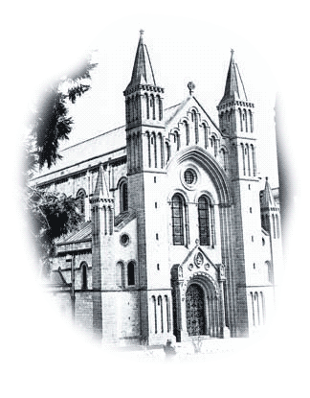
This year’s Annual Dinner & Prize Giving is being held at the Grange Restaurant at Buckfast Abbey from 6:30 pm until 11:00 pm.

We welcome Zsolt Schuller as our speaker this year. Zsolt is the Cycle Exeter Project Manager and has been responsible for developing over 20 km of new cycle routes in and around Exeter as well as introducing a substantial cycle training programme for both adults and children.

This year there will be another collection of bikes on display.

The meal will commence at 7:00 pm prompt to ensure we complete the proceedings well before the closing time to give time to look at the bikes and to socialise.  Ticket price £17:50  Please return the form below with your name & meal choice and give it to your Section Secretary or send it to Kirby James at 16 St Briac Way, Exmouth, EX8 5RN with cheques payable to  CTC Devon DA, |  | Christmas Menu:  Soup or Fruit Juice  --------------------  Roast Turkey with Stuffing,  Cranberry Sauce & Chipolatas  or  Roast Beef & Yorkshire Pudding  or  Vegetarian Option  All served with Roast Potatoes & Fresh Vegetables  ------------------  Christmas Pudding  -----------------  Mince Pies with Clotted Cream  ----------------  Coffee & Petits Fours
NAME:
----------------------------------------------------------------------------------------------------------------------------

MEAL (CIRCLE CHOICE): Starter: SOUP FRUIT JUICE

Main: TURKEY BEEF VEGETARIAN

